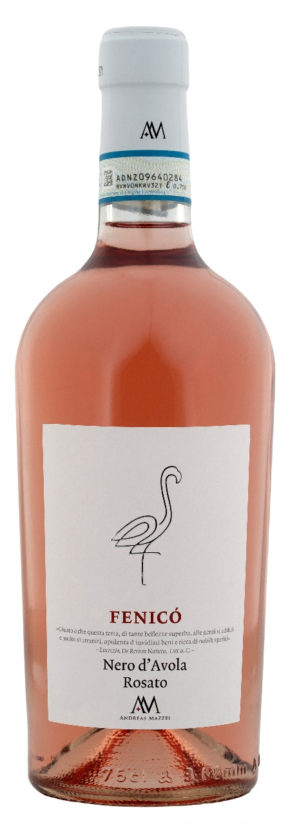
NERO D’AVOLA ROSATO DOP – FENICO

Grape: Nero d’Avola 100%
Alc. Vol.%: 12
Vintage: 2025
Residual sugar g/l: 5,0
Total acidity g/l: 5,6
Region: Sicily
Production zone: Vineyards in the province of Trapani
Capacity: 750ml

CHARACTERISTICS

Vinification: Short maceration of the skins on the must at 0°, then separation and fermentation at a controlled temperature
Aging: In steel tanks until bottling
Yield per ha: 12000kg
Colour: Light and bright rosé
Bouquet: Fresh with notes of watermelon and cherry
Flavour: Well-balanced and pleasant

SERVING SUGGESTIONS

Perfect as an aperitif or with fish courses.
Serving temperature 10 °C
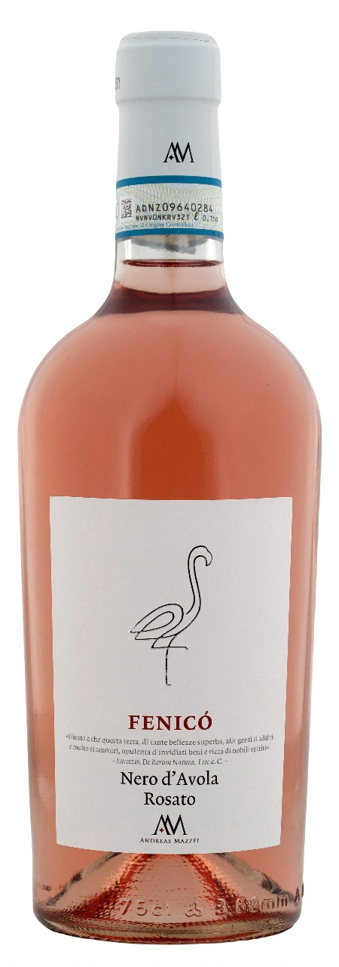
TECHNICAL INFORMATION / PALLETIZING

Size 750ml:
Article Nr. V04006A
GTIN-13 bottle 8017868006343
GTIN-13 carton 8017868006350
Closure Cork
Bottles / carton 6 bottles
Pallet size 80x120cm
Cartons/layer 17
Cartons/pallet 102
Kg/carton 10
Kg/pallet 820

Contains sulphites
GMO Free
Revisione 01. 10.03.2025

